Findhorn Bay Arts is looking for professional artists to deliver a range of creative activity:
- Theatre, Dance, Visual Art, Music, Comedy etc. for the 3rd Findhorn Bay Festival
- Headline artists for Multi-Cultural Music & Food Event, part of the Making More of Moray project
- Live Music Sessions, part of the Making More of Moray project
Please note we are also seeking artists for Making More of Moray Out n About activity on Culture Day Forres and at Picnic in the Park. Please click here to find out more.
Artist Criteria
- Demonstrate experience in delivering professional performances/activity
- Demonstrate quality of work
- Out n About activity can include, for example, storytelling, visual art, dance, music, theatre, circus, walk about performances. Activity be delivered continuously or at regular intervals and it must be self-contained (e.g. you provide everything you need)
- Activity must be suitable to engage with people of all ages
- Artists must have their own Public Liability Insurance
Application
To find out more about the application process and to submit a proposal please contact:
director@findhornbayarts.com | 01309 673137

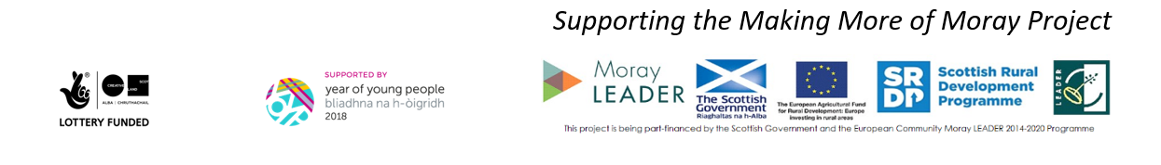

Artist Application

- Please indicate which activity you are applying for
select all that apply
☐ Theatre, Dance, Visual Art, Music, Comedy etc. for the 3rd Findhorn Bay Festival
☐ Headline artist for Multi-Cultural Music & Food Event, part of the Making More of Moray project on Friday 28 September 2018
☐ Live Music Sessions, part of the Making More of Moray project
For Out n About activity on Culture Day Forres and at Picnic in the Park, part of the Making More of Moray project, please see separate application

- Artist Name

- Please detail how your work meets the artist criteria

- Pease describe your proposed performance / activity

- What is the cost of your performance / activity

- Please provide links to your work, biographies, reviews etc.

- Additional Information
please supply any other information or notes you would like us to know about here

Agreement
By submitting this form, you confirm that the given information is correct, that you will adhere to the roles and responsibilities of performing and supply copies of all required certification (e.g. public liability insurance).

For Administrative Purposes
Contact Name:
City/Town:
Postal Code:
Email Address:
Phone Number:

